MEDICAL ADVICE DISCLAIMER
The information contained, including but not limited to text, graphics, images and other information sources, is made available for information and educational purposes only. We are not medical providers, mental health care providers, or any kind of medical professionals and this content does not constitute or replace nor be substituted for professional medical advice, diagnosis or treatment.
Always seek the advice of your physician or other qualified health provider with any questions you may have regarding a medical condition. If you have or suspect that you have a medical or mental health problem, never disregard professional advice and contact your medical provider or mental health care provider promptly.

THE PRODUCTS ARE NAMED FOR THE SYSTEM THEY SEEM
TO SUPPORT.

FOR FURTHER INFORMATION OR TO PLACE AN ORDER, CALL THE OFFICE AT 1-800-258-8589 or 503-631-7389

FOR THE HEALTH OF PEOPLE AND ANIMALS

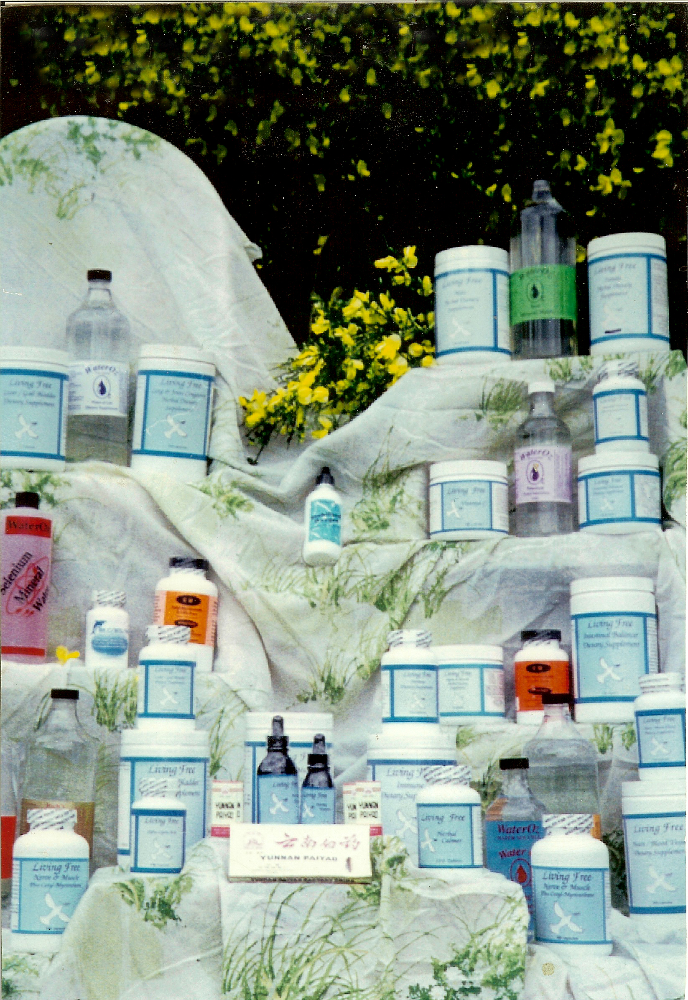
BOOK: SEASONS, MY JOURNEY THROUGH THE THREE DIMENSIONS OF NATURAL HEALING
By Beatrice Lydecker-Hayford $16.95

PRODUCT DESCRIPTION AND PRICES
Living Free is the Brand Name for the People Products, Formulas are named after the organs they support.

The four step program comes with nearly a 6 month supply of many of the items needed.
- One 500 count bottle of Immune capsules
- One 500 count bottle of Liver Gallbladder capsules
- One 500 count bottle of Adult Extra capsules, a potent multiple vitamin
- Two 60 count bottles of Noni
- One 100 count bottle of Kidney capsules
- Two 2 ounce bottle of Zeolite
- One 32 ounce bottle of Copper solution

THE SHORT PROGRAM
PRODUCTS NEEDED:
- One Immune bottle of 100 capsules
- One Liver/Gall Bladder bottle of 100 capsules
- One Adult Extra bottle of 100 capsules
- One Kidney bottle of 100 capsules
- One Noni bottle of 60 capsules
- Two bottles of Zeolite 2 ounces
- One 32 ounce bottle of Copper solution.

ADULT EXTRA: Our proprietary blend is a basic Adult formula which includes: Vitamin A (palmitate), Vitamin C (calcium ascorbate), Vitamin D (cholecalciferol), Vitamin E (from natural d’alpha tocopherol), Vitamin K1, Thiamin (HCI), Riboflavin, Niacin, Niacinamide, Vitamin B6 (from pyridoxine HCI), Folic Acid, Vitamin B12 (cyanocobalamin), Biotin, Pantothenic Acid (from d-calcium pantothenate), Choline (Bitartrate), Calcium (ascorbate and citrate), Iron (amino acid chelate), Magnesium (amino acid chelate), Zinc (amino acid chelate), Selenium (amino acid chelate), Copper (amino acid chelate), Manganese (amino acid chelate), Chromium (amino acid chelate), Molybdenum (aspartate), Potassium (chloride), Bentonite, Soy Lecithin, Borage Oil Powder, Hydrolyzed Collagen (Chicken), Liver Powder (Bovine), Kidney (Bovine), Heart (Bovine), Kelp (Organic), Natural Trace Minerals, Garlic Bulb (Organic), Citrus Bioflavonoids, Yucca Root, Pancreas (Bovine), DigeZyme® enzymes, Para Amino Benzoic Acid (PABA), Thymus (Bovine), Inositol, Thyme, Slippery Elm Bark, Vanadium (amino acid chelate), Lactobacillus Acidophilus (1.3 Million CFU). Cellulose (from capsule shell), magnesium stearate, and silica. Recommended for any adult desiring a very complete, potent formula for general nutrition.
100 Capsules---$23.00 500 Capsules---$70.00
ARTHO FLEX: Cetyl-Myristoleate
180 Capsules---$60.00 500 Capsules---$125.00
CALMERS-LIVING FREE: (Valerian, passion flower, black cohosh, calcium citrate, niacin-amide, wild lettuce, hops, magnesium oxide, vitamin B-6, thyme leaf, magnesium phosphate (cell salts).
This proprietary blend sells for:
100 capsules---$16.00 500 Capsules---$55.00
DIGESTION: A proprietary blend of (Garlic, Lactobacillus acidophilus, peppermint, dandelion, slippery elm, parsley, chicory, Irish Moss, yarrow, pancreas tissue, thyme leaf, agrimony, adrenal tissue, hyssop, cascara sagrada, lobelia, cayenne). .
100 capsules---$23.00 500 Capsules---$70.00
Enzymes Plus: (Magnesium oxide, B-6, (Pyridoxine HCL) Protease, Papain, Bromelain, Cellulase, Serrapeptase, Chymotrypsin, Rutin plus Nattokinase). This proprietary blend uses proteolytic enzymes. This blend is combined with Magnesium and B-6. If you have any questions, contact your health care provider.
180 Capsules---$48.75 500 Capsules---$97.50
FOOT SOAK: (Zinc, Potassium, Barium, Iron, Sodium, Calcium, Copper, Chlorophyllin, Sanguinaria Canadensis, Impatiens pallida, Hydrasis Canadensis, Ferula galbaniflua, Hydrastus perforatium, Rubus villosus, Fumaria officinalis, Frasera carolinensia, Allicin, Garlic) It includes the equivalent of Two-2 ounce bottles of herbal extract along with other nutrients that support the body. Comes with a soaking pan ---$495.00
HEART AND BLOOD VESSEL: Heart tissue (Bovine), Ginkgo biloba leaf, Hawthorn Berry (Crataegus laevigata), Ginseng (Eleutherococcus senticosus), Hyssop Herb (Hyssopus officinalis), Wood Betony Herb (Stachys officinalis), Garlic Bulb (Allium sativum), Devil’s Claw Root (Harpagophytum procumbens), Liver (Bovine), Horsetail Herb (Equisetum arvense), Ginger Root (Zingiber officinale), Cayenne Pepper (Capsicum annuum), Citrus Pectin, Soy Lecithin, Quercetin, L-Carnitine Fumarate.
This proprietary blend sells for:
100 Capsules---$26.00, 500 Capsules---$80.00
HERBAL COMPOUND: Is essentially the same as the Herbal Extract except for the balances of the individual herbs but we have removed Galbanum and added Asafoetida Gum Powder. Each capsule is essentially equal in potency to 4 or 5 drops of the Herbal Extract.
This proprietary blend sells for:
180 Capsules $65.00 500 Capsules $125.00
HERBAL EXTRACT:(Saint John’s wort, blackberry, bloodroot, jewel-weed, goldenseal, galbanum, fumitory, elk weed, Gentian, garlic, chlorophyll, trace minerals). This proprietary blend tincture is made in the United States which I private label. It supports the body’s natural defense. It is suggested you take this formula with the Liver and Immune. 1 ounce bottle of 600 drops---$110.00
2 ounce bottle of 1200 drops---$175.00
HYALURONIC natural skin moisturizer. This is vital in restoring hydration to the skin, also called SYNOVIAL 7 The Hyaluronic acid we use is extracted by a special process from the combs of roosters. A bottle contains about 30 doses at one eyedropper per day in a glass of water. If you have any questions, contact your health care provider.
One ounce bottle---$45.00
HYLAVISION: Contains Hyaluronic Acid to maintain fluid balance in the eye. Lutein/Zeaxanthin Complex (marigold) vitamin A, vitamins B2, C, E, and Zinc. If you have any questions, contact your eye doctor. $24.98
HYLARUB: (Water, Hyaluronic Acid to lubricate joints, Cetyl Oleate, Emu Oil to penetrate deep into the skin, Emulsifying Wax, Glycerin, Stearic Acid, Cetyl Alcohol, L-Arginine, Peppermint Oil, Hyaluronic Acid, Lactoperoxidase, Glucoseoxidas Glucose, Capsaicin from Cayenne Pepper. A non greasy moisturizing cream. External use only. 6 ounce tube---$45.00
IMMUNE: (Thymus Substance (Bovine, Argentina), Kidney Powder (Bovine, Argentina), Lactobacillus acidophilus (10 BillionCFU/gram), Heart Powder (Bovine, New Zealand), Organic Echinacea angustifolia Herb, Liver Substance (Bovine, New Zealand), Thyme Leaf (Thymus vulgaris), Collagen (Type I and III Chicken), Pancreas Substance (Bovine, Argentina), Soy Lecithin, Pancreatin 3X, Dandelion Root Powder (Taraxacum officinale), Adrenal Substance (Bovine, Argentina), Milk Thistle Extract (80% Silymarin). Cellulose (from capsule shell), Magnesium Stearate, and Silica. This proprietary blend sells for:
100 Capsules---$30.00 500 Capsules---$110.00
Net Wt. 1/2 lb.---$65.00 Net Wt. 1 lb.---$85.00
KIDNEY & BLADDER: Kidney Tissue (Bovine), Thymus Tissue (Bovine), Organic Stinging Nettle Leaf (Urtica dioica), Cranberry Fruit (Vaccinium macrocarpen), Pancreatin Powder (Porcine), Ascorbic Acid, Vitamin E (d-alpha tocopherol succinate), Dandelion Root (Taraxacum officinale), Organic Echinacea angustifolia Leaf, Onion Bulb (Allium cepa), Gotu Kola Aerial Parts, Organic Alfalfa Leaf (Medicago sativa), Organic Garlic Bulb, Liver Tissue (Bovine), Thyme Leaf (Thymus vulgaris), Organic Uva Ursi Leaf (Arctostaphylos uva ursi), Cellulose (from capsule shell).
This proprietary blend sells for:
100 Capsules---$25.00 500 Capsules---$80.00
Net Wt. 1/2 lb.---$38.00 Net Wt. 1 lb.---$60.00
LIVER/GALLBLADDER: Burdock Root (Arctium lappa), Liver (Bovine), Yellow Dock Root (Rumex crispus), Kidney Tissue (Bovine), Agrimony Herb (Agrimonia eupatoria), Garlic Bulb (Allium sativum), Pau d’Arco Bark (Tabebuia heptaphylla), Cinnamon Bark (Cinnamomum burmanii), Yarrow Flower (Achillea millefolium), Dandelion Root (Taraxacum officinale), Oregon Grape Root (Mahonia aquifolium), Rosemary Herb (Rosemarinus officinalis), Chicory Root 4:1 Extract (Cichorium intybus), Horseradish Root (Aromoracia rusticana), Barberry Root (Berberis vulgaris), Milk Thistle Seed PE (80% Silymarin, Silymarin marianum), Irish Moss (Chrondus crispus), Clove Bud (Syzgium aromaticum), Red Root (Ceanothus americanus), Buckthorn Bark (Rhamnus frangula), Fumitory Herb (Fumeria officinalis). Gelatin (from capsule shell), Ethylcellulose, and L-leucine.
This proprietary blend sells for:
100 Capsules---$30.00 500 Capsules---$92.50
Net Wt. 1/2 lb.---$65.00 Net Wt. 1 lb.---$85.00
LUNG AND JOINT: (Lung tissue, coltsfoot, thyme leaf, hydrolyzed collagen, hyssop, mullein, Echinacea, pau d’arco, myrrh, soy lecithin, Irish moss, horseradish, lobelia, cayenne, parsley, vitamins E- Succinate & C- ascorbic acid). Consult your veterinarian when using this product with horses that are bleeders or have heaves.
This proprietary blend sells for:
100 Capsules--$25.00 500 Capsules$75.00
Net Wt. 1/2 lb. $38.00 Net Wt. 1 lb. $50.00
NERVE & MUSCLE PLUS CETYLMYRISTOLEATE: This proprietary blend combines 50% Cetyle Myristoleate and 50% the Nerve and Muscle proprietary blend (Scullcap, Rosemary 4:1 Extract (Rosemarinus officinalis), Bentonite Clay, Wild Lettuce Leaf Herb (Lactuca sp.), Alfalfa Leaf Powder (Organic, Medicago sativa), Hydrolyzed Collagen Powder (Chicken), Red Clover Blossom (Organic, Trifolium pratense), Thyme Herb Powder (Thymus vulgaris), Skullcap Herb Powder, Dandelion Root (Taraxacum officinale), Lecithin, Echinacea Root (Echinacea angustifolia), Thymus (Bovine), Black Cohosh Root Powder (Cimifuga racemosa), Pancreatin 3X, Milk Thistle Seed Extract (80% Silymarin, Silybum marianum). Cellulose (from capsule shell), Magnesium Stearate, and Silica.
180 Capsules---$55.00 500 Capsules---$110.00
NONI: The Noni we carry is made from a small evergreen tree found growing in virgin, mineral rich, organic lava beds along the coastlines and forests of Hawaii. Since Xeronine is not present in nature, the body must make it. Noni stimulates that process. That is why it is called a ProXeronine.
60 Capsules---$25.00 120 Capsules---$45.00
PREVAGEN: According to the manufacturer it helps restore memory loss. Comes in two sizes and three strengths. Some discounts apply.
Manufacturer recommends one capsule per day.
10 mg………………………………….30 capsules $39.95 60 capsules $74.95
Extra Strength 20 mg………............. 30 capsules $59.95
60 capsules $109.95
Professional Strength 30mg…………. 30 capsules 79.95
LIQUID ZEOLITE: Many years ago, volcanoes erupted and poured lava into the sea. The combination of lava, ash and salt from the sea, caused a chemical reaction which, over thousands of years, resulted in what is now known as Zeolite. It formed in the hardened lava that is harvested and used by many throughout Asia for centuries as part of their traditional remedies to promote overall health and well being. $25.00 per bottle

MINERAL SOLUTIONS AND WHAT THEY DO
Dr. Henry Schroeder, M.D., PhD of Dartmouth University said, “Your mineral needs are even more important than your vitamin needs, since your body cannot make minerals”. Your body needs not only minerals found in large quantities. it also needs many trace minerals. Medical science has proven beyond any doubt that the body can absorb essential minerals in solution form far more rapidly than in a pill, powder, colloidal or any other form. Before now, the only way to get the minerals was through (1) food, in an ionic/water soluble form, but seldom found in large enough quantities; (2) from capsules or tablets that are virtually ineffective, and (3) from colloidal mineral waters that are not truly absorbable or useable by the human body as their minerals are in particles and are not water soluble.
Clear River dietary supplements in the form of mineral waters, which are what we sell, are made by a technical, revolutionary new process with the end result being 99.99 pure water soluble minerals. This technical process turns pure minerals into an ionic/water soluble solution. The water used for the suspension is drawn from a subterranean spring for purification and processed by reverse osmosis, then treated with ozone before the mineral solution is added to produce the finished product.
Calcium
Chromium
Copper
Gold and silver
Iron
Magnesium
Selenium
Sulfur
Vanadium
Water of Life---A balance of minerals
Zinc 16 ounces $25.00 / 32 ounces $35.00 / gallon $60.00

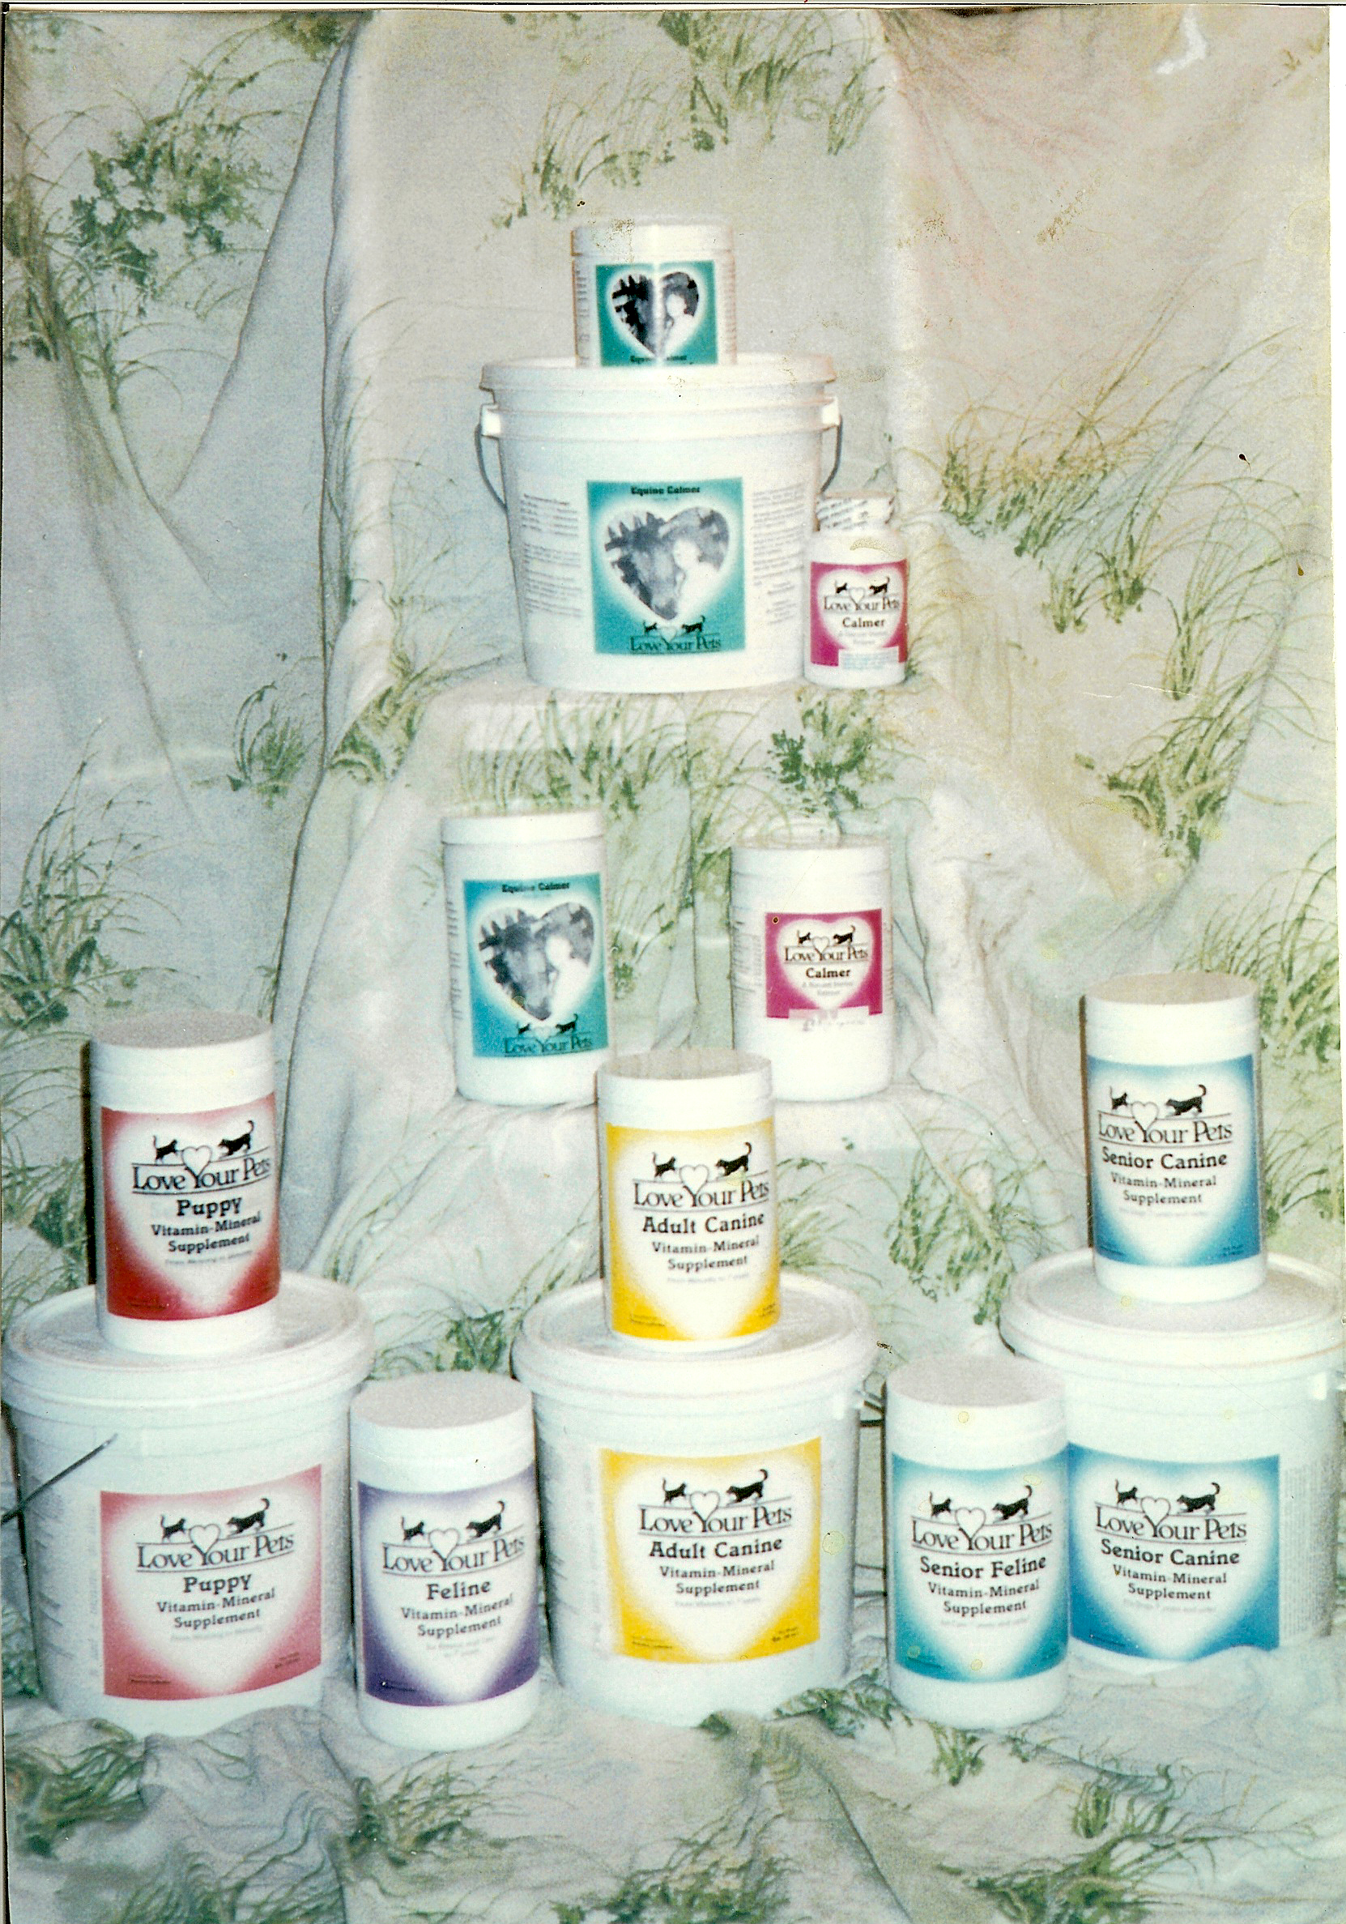
“You Too Can Talk With the Animals”
A total revision of What the Animals Tell Me and Stories the Animals Tell Me plus a chapter, “Pets Do and Say The Darndest Things”, funny things that have happened during my career talking with animals. Section three details the techniques of how you too can learn to talk with the animals and get answers.
Book only $19.95
DVD You Too Can Talk With the Animals Seminar teaching the techniques of how to talk with the animals and get answers, along with training tips and demonstrations. $24.95
You Too Book and DVD Set $34.95

LOVE YOUR PETS PRODUCT

LOVE YOUR PETS CALMERS: Valerian Root, passion flower, black cohosh, calcium citrate, niacinamide, wild lettuce, hops, magnesium oxide, vitamin B-6, thyme leaf, magnesium phosphate (cell salt).
This proprietary blend sells for:
100 capsules $16.00 500 capsules $55.00
EQUINE CALMER A proprietary blend of Valerian root, black cohosh, wild lettuce, skullcap, rosemary, hops, thyme leaf. If you have questions, consult your veterinarian.
Net Wt. 1/2 lb. $20.00 Net Wt. 1 lb. $30.00
EQUINE ARTHOFLEX: A proprietary blend of Cetyl-myristoleate, skullcap, rosemary, alfalfa, collagen, trace mineral complex, red clover, wild lettuce, dandelion root, Echinacea, thymus, soy lecithin, enzyme complex, black cohosh, milk thistle.
Net Wt. One Pound---1 month supply-- $125.00

We use the people products with the animals, usually in
powder form.
CONVENIENCE ITEMS

GELATIN CAPSULES size 00, 1000 to a package $25.00
Encapsulating Machine for 00 Capsules $15.00
Roll of pH test strips (can test up to 150 times) $12.00
STABILIZED OXYGEN: Drops oxygenate the water. Never take in any acidic juice as it breaks the bond, releasing the oxygen in the juice, not in you.
Recommend 10 drops as needed in water only. $ 15.00
Yunnan Baiyo 1-6 capsule tray or bottle of powder
This product was developed by a company in the Yunnan Province of China to stop or control bleeding in soldiers that were wounded until they could get medical intervention. $10.00 each

Two very important Homeopathic items that should be on everyone’s shelf and in every one’s vehicle, are Arsenicum Album that stops food poisoning and Pyrogenium that stops poisoning from everything else.
VERIFY WITH A HOMEOPATHIC PROVIDER.
Each bottle comes with a dispenser so you can get the pellets out of the bottle without touching them as you drop them on the tongue. It is very important not to handle the pellets because it will contaminate them. This works the same for animals as it does for people.
Each bottle is $10.00

MOST RECENT BOOK
BY BEATRICE LYDECKER-HAYFORD
‘WALKING THE THIN VEIL’
In this book I relate the experiences I have had with angels and phenomenon that cannot be explained from a physical
perspective. $14.95

We now ship by US postal service either by Priority mail, regular or flat rate, or parcel post. The need for faster service became especially important after closing the center in Kentucky so that all orders now originate from our Oregon office. We are happy that Priority mail makes faster delivery to the East Coast possible, so we ship by priority regular or priority flat rate and only use parcel post, for larger orders which takes just about the same delivery time as UPS or Fedex, but at a much lower rate. In order to keep your cost as low as possible, we are no longer charging a percentage for shipping and handling, but will stay close to what the post office actually charges us. There will be an extra charge for COD or overnight delivery, but again, only what the post office charges us.
All sales are final once they are opened. Since herbs are a food, we cannot take any item back once the seal is broken. For all unopened product returns, a restocking fee of 10% plus the shipping costs we were charged in getting the order to you will be deducted from your refund.

There will be no refunds or exchanges after 30 days

With the purchase of each program you receive a free copy of my book, “SEASONS, MY JOURNEY THROUGH THE THREE DIMENSIONS OF NATURAL HEALING”. The book fully explains the Simian 40 virus and the diseases it causes as well as the emotional aspects of illnesses.

A 5% discount is offered to anyone over 65.
A 5% discount is offered if you can provide me with an email address. This saves me money, and time when sending out newsletters and updates, well worth the discount.

